Marine Safety Enhancement Using Faster R-CNN with VGG16 for Ship Detection from Airborne Radar Signals

Sea monitoring for ship detection is done by marine peoples for sea safety and to avoid illegal fishing. Existing techniques were using Automatic Identification System (AIS) and marine radar for ship detection but all ships will not be equipped with AIS system so their detection will not be possible. Radar signals will be evaluating using constant false alarm rate (CFAR) which will analyse pixels from each signals and may predict wrong object as ship.
To overcome from above problem author of this paper employing Faster R-CNN which will get trained on Airborne Compressed Radar Data which will obtained from Airborne flight radar signals and not required any AIS installation at the ship side. Airborne signals contain two different data such as Time Domain and Doppler domain. Faster-RCNN will trained on both data and then used time signals to detect object and Doppler signals to classify object. Faster RCNN is region based detection algorithm which will analyse each region to detect desired object and avoid false detection.
In propose work author used Resnet50 as the base model for Faster RCNN and then train FRCNN with Airborne dataset.
Extension Concept: Resnet50 is the old model and Faster RCNN accuracy can be enhanced by employing advanced models so in extension work we have employed VGG16 as the base model for FRCNN and this algorithm giving high accuracy compare to propose FRCNN. Both algorithm performances are evaluated in terms of Accuracy, Precision, Recall and FSCORE.
For training we have used Airborne dataset radar signals which are available in JSON file and this file is in huge size so we cannot open in normal Notepad but can be read and process using application. Extracted signals can be converted to images for testing
In below screen we are showing JSON based dataset file
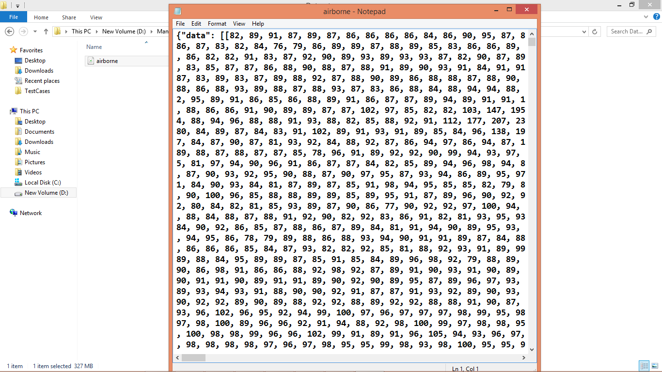
In above screen we can see dataset signals and by using this dataset we will train and test models
SCREEN SHOTS
To run these project double click on run.bat file
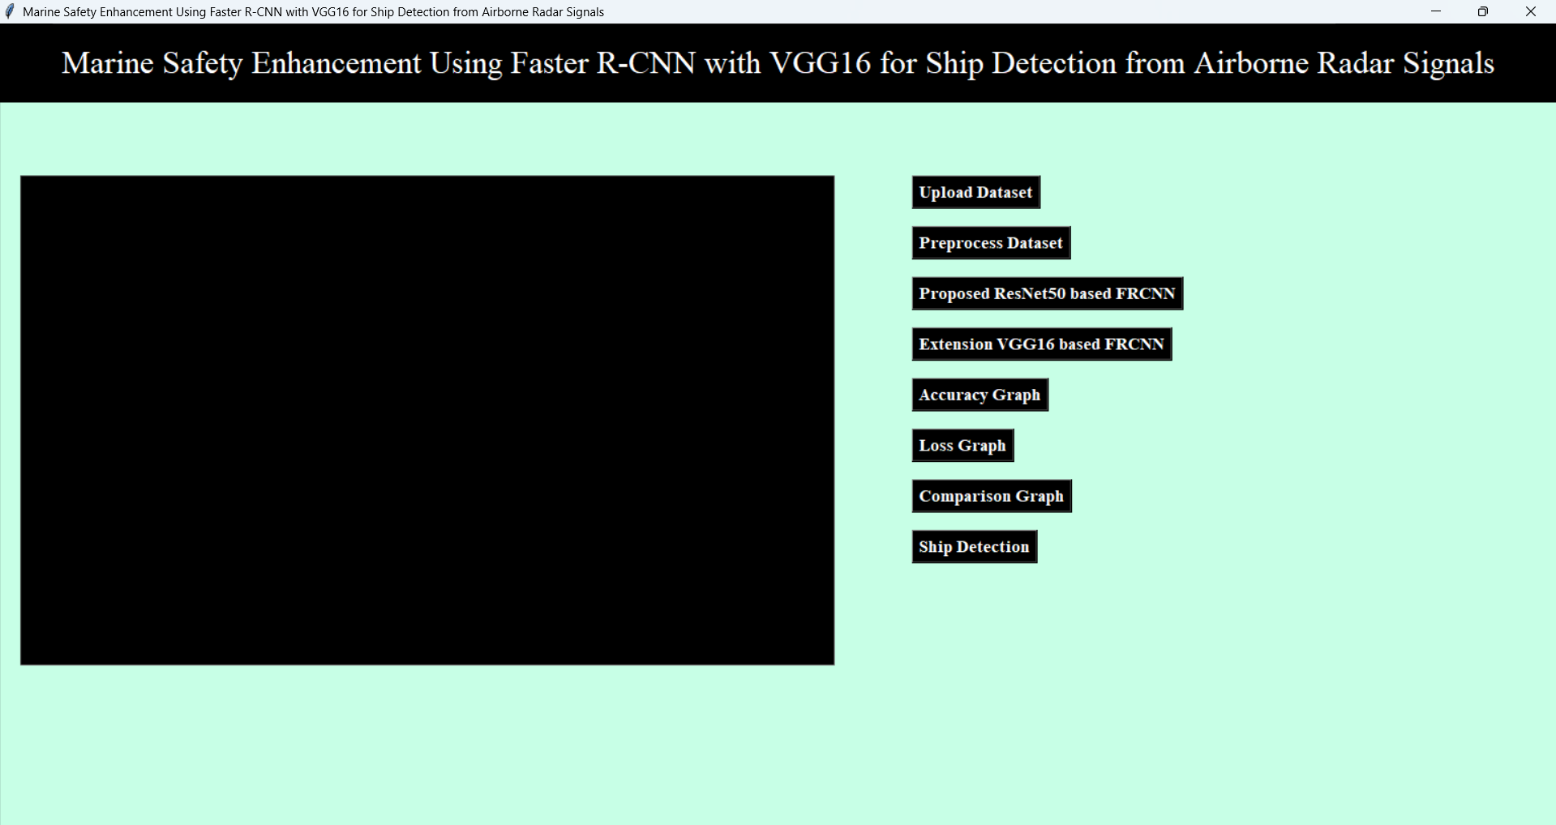
In above screen click on ‘Upload Dataset’ button to get below output
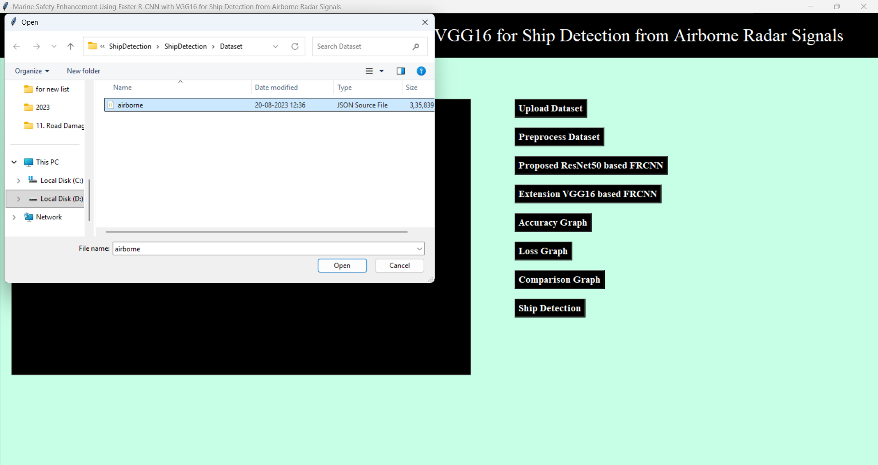
In above screen select ‘airborne.json’ file dataset and click on open button then we will get below output
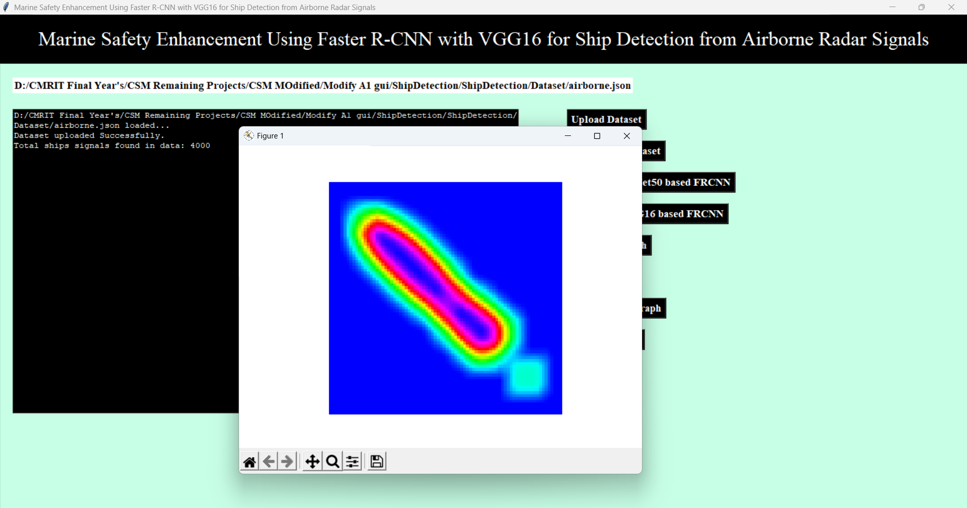
In above screen loading dataset and then extracting key from dataset where data key contains signals and labels contains class label values and then displaying total ship signals found in dataset as 4000. A graph represents converting all signals in to images and then displaying sample image. Now click on Preprocess Dataset button to get below result
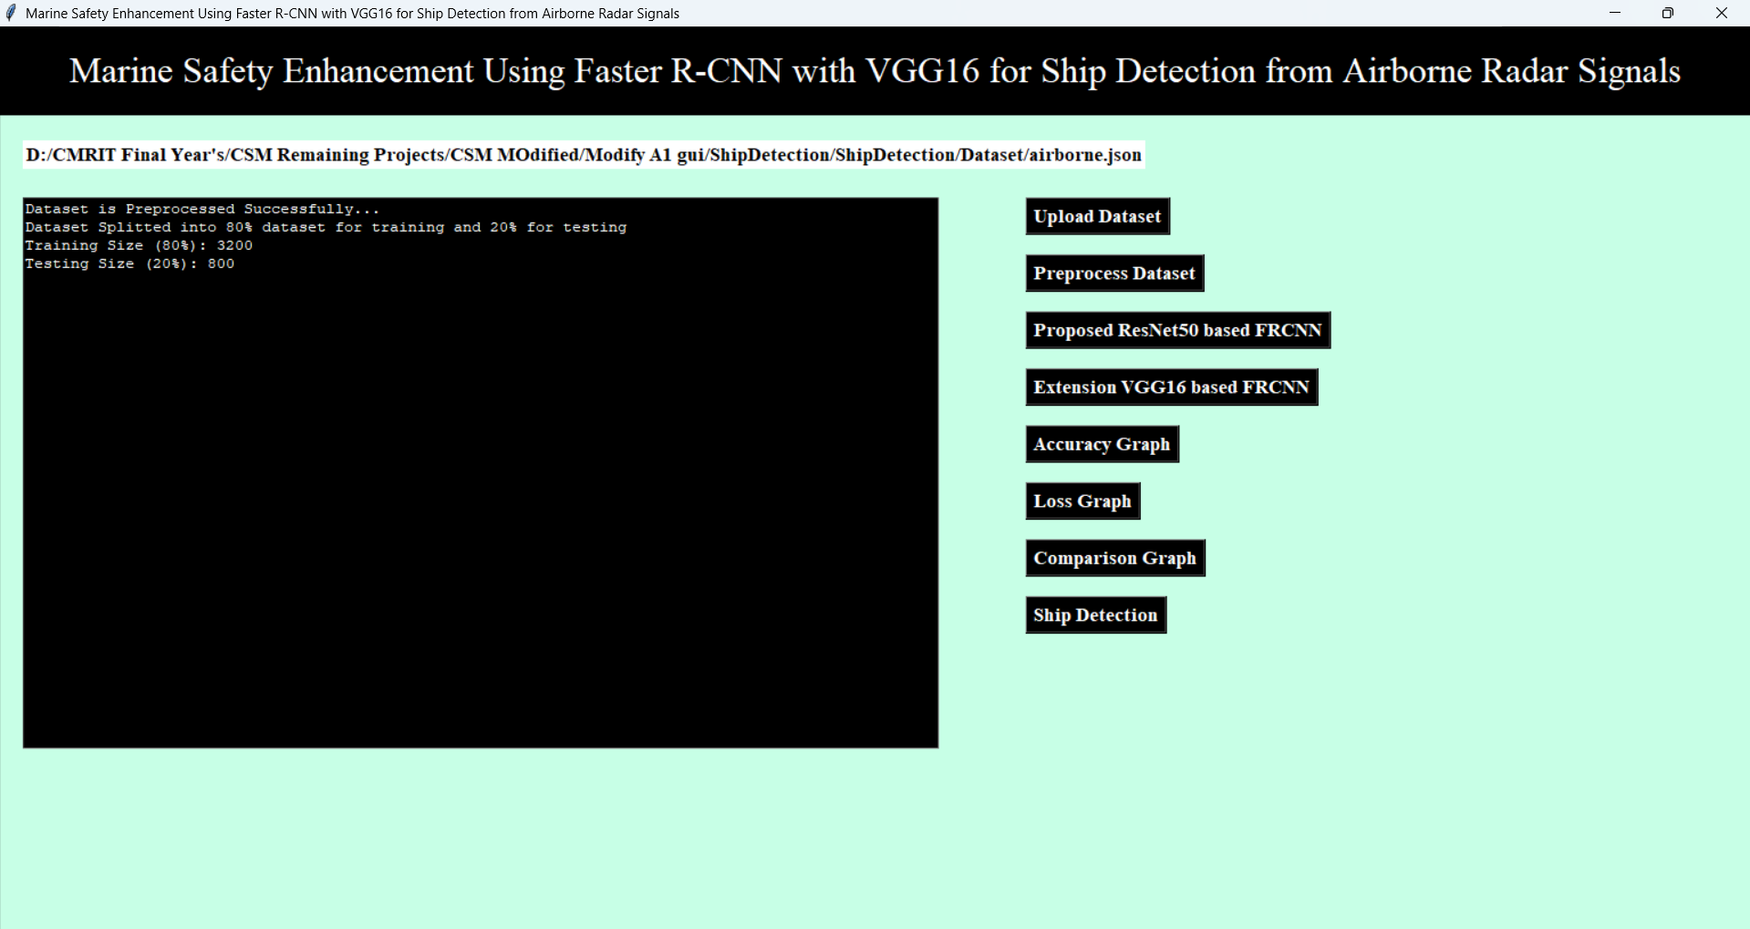
In above screen pre-processing all images like shuffling and normalizing and then displaying normalize values. After pre-processing we split the dataset into training and testing dataset. Now click on ‘Resnet50 based FRCNN’ to get below result
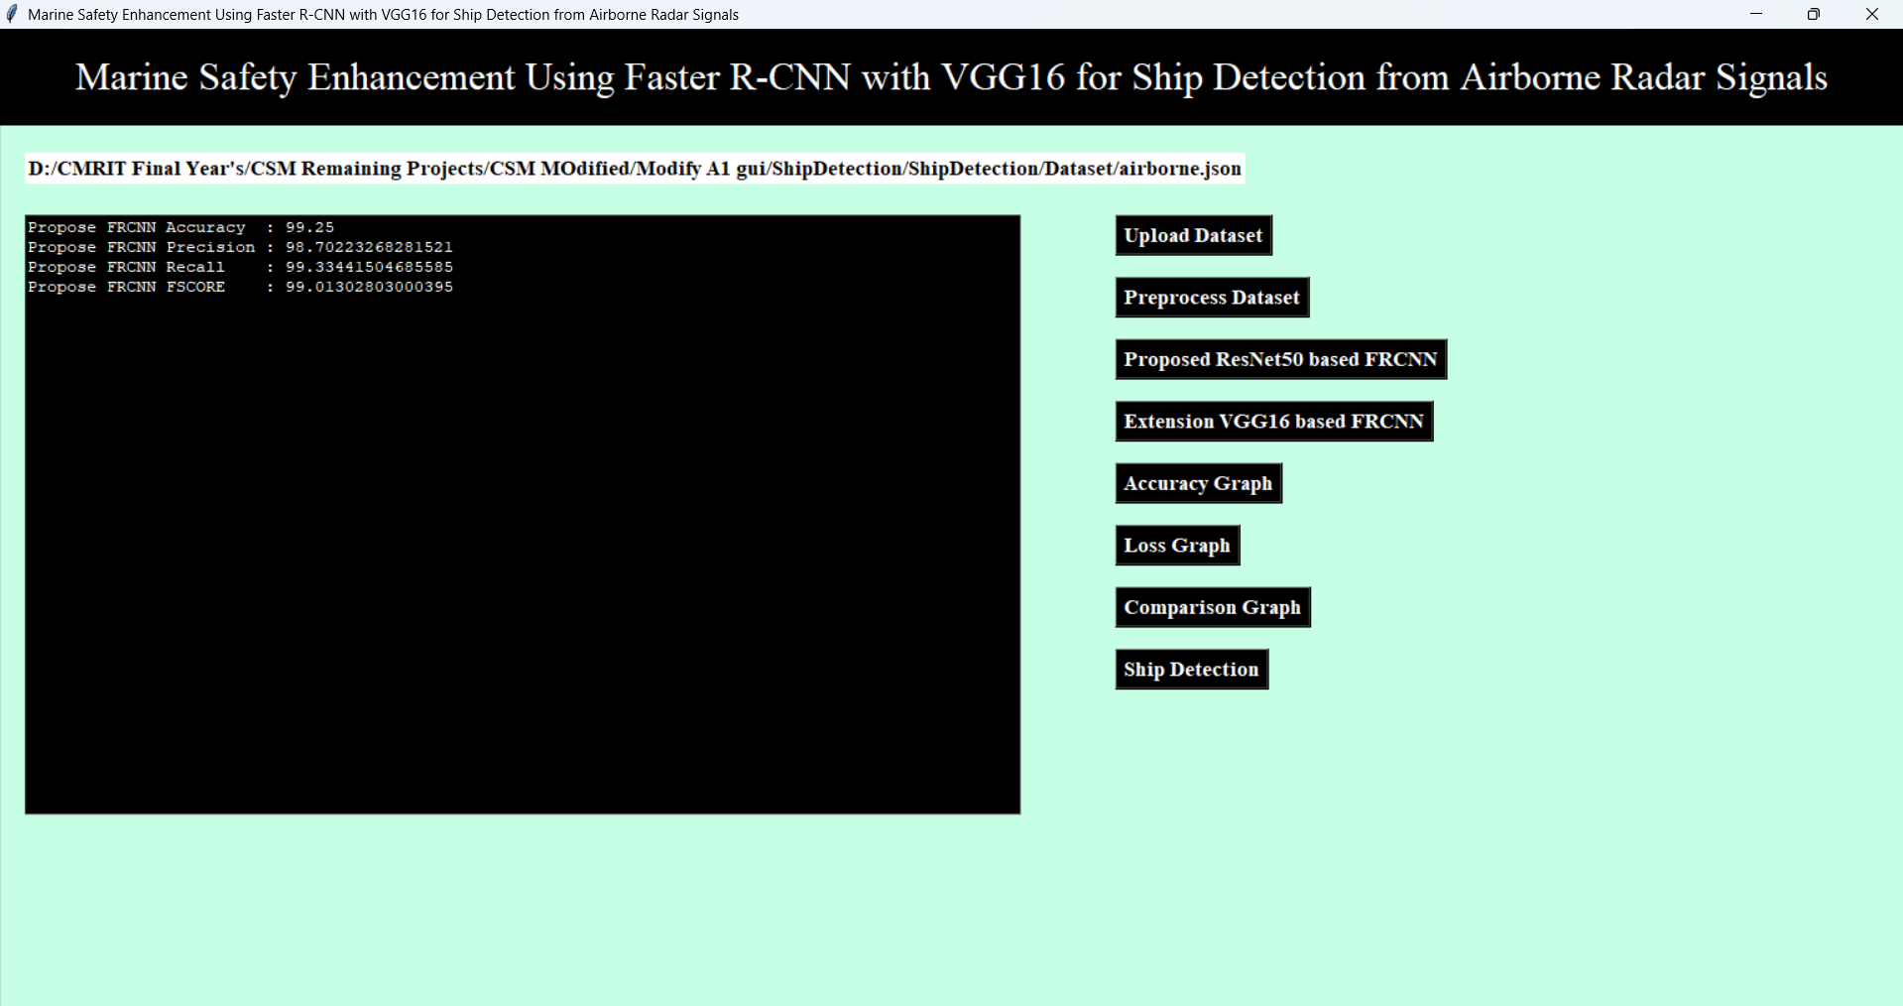
In above screen training FRCNN by using Resnet50 as the based model and after testing this model we can see propose FRCNN accuracy is 98+% or and can see other metrics also. Now click on ‘VGG16 based FRCNN’ to get below result
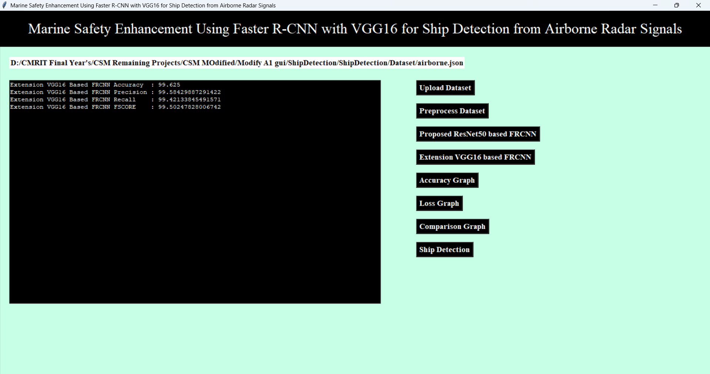
In above screen training extension FRCNN by using VGG16 as the based model and after executing this model with extension model we got 99+% accuracy (always we will get accuracy higher than proposed method and sometime we will get 100% accuracy). Now click on ‘Accuracy Graph’ to get below result
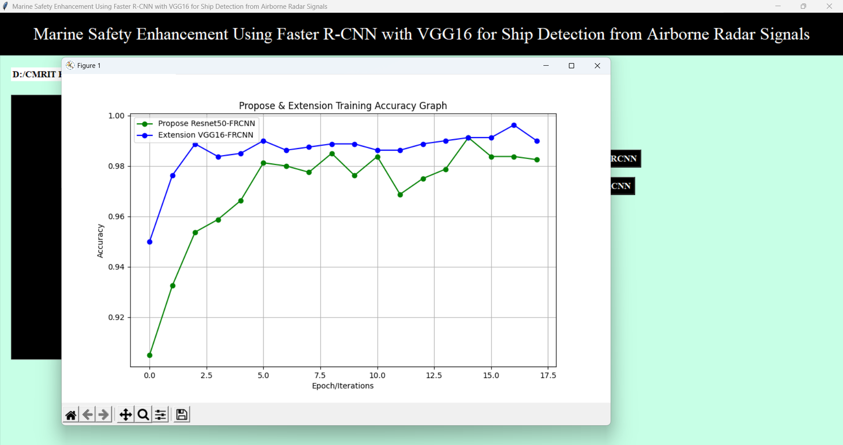

Above is the Propose FRCNN and Extension FRCCN training graph where x-axis represents training epoch and y-axis represents training accuracy. Green line represents propose FRCNN accuracy and blue line represents extension FRCNN accuracy and with each increasing epoch accuracy got increase for both models but extension got high accuracy. Now click on ‘Loss Graph’ to get below result
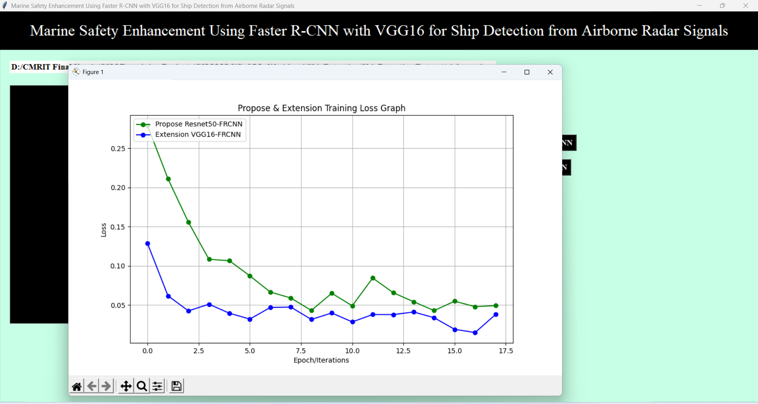
Above is the Loss graph for both model and extension got less loss compare to propose algorithm. Now click on ‘Comaparison Graph’ to get below result
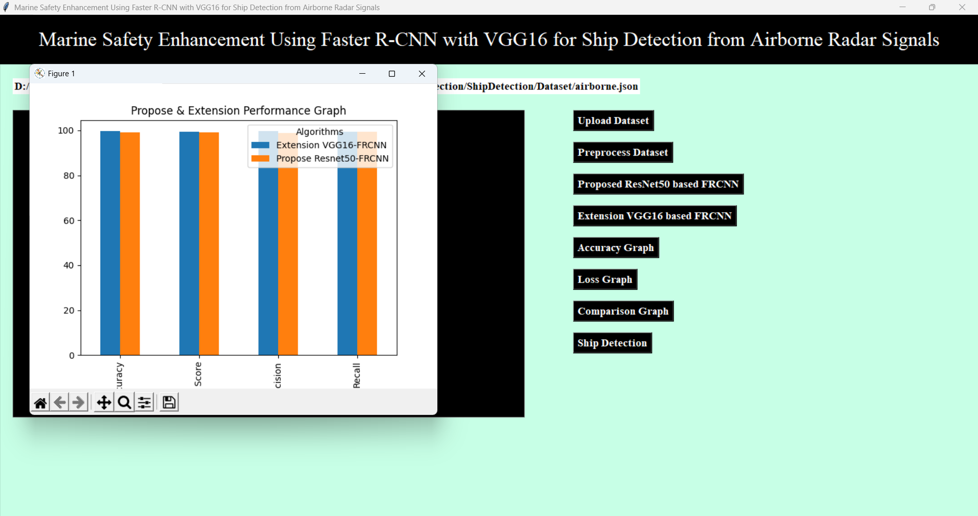
In above graph x-axis represents algorithm names and y-axis represents accuracy and other metric in different colour bars displaying both algorithm performance in graphical format. Now click on ‘Ship Detection’ to get below result
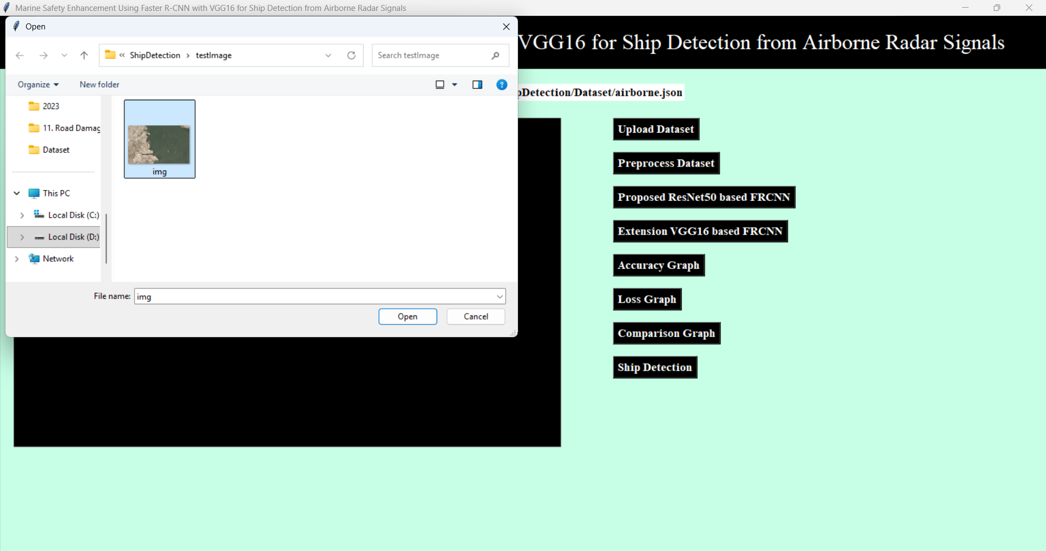
In above screen giving input image for detection and after detection will get below output
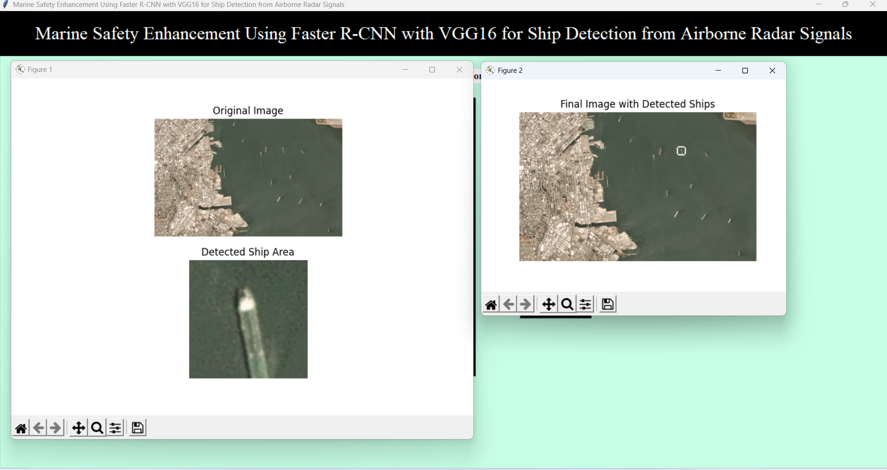
In above screen detected ship displaying with while bold colour bounding box and it classify as ship and putting bounding boxes across it. In image lots of ships are there and for all detection model may take hours of time so we are detecting only one ship and then breaking the loop.
Note: above image is captured from airborne flight

